Eclipse notes

1. Launch eclipse
2. Select a workspace on H drive (H:\APCS\workspace)
3. File-new-java project
   1. Leave defaults

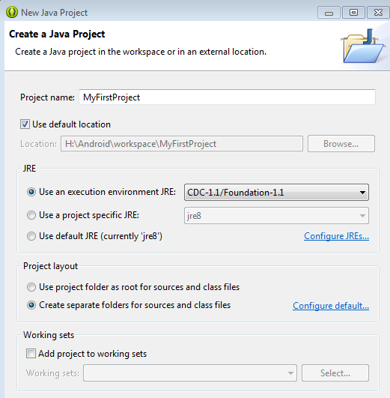

* 1. Select Finish

1. Create or drag template file into src folder under project folder
   1. For first project, drag a file into your src folder (get the file from google classroom)
   2. For file operation dialog box, select copy files

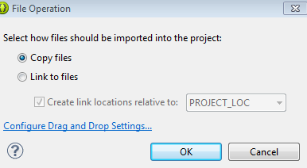

* 1. Should now have a java file in your src/default package folder

1. Project-build All
   1. Project clean will force the compiler to start from scratch
   2. May get a warning but shouldn’t have any errors

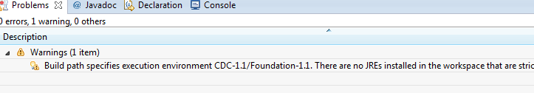

1. Run 🡪 output will be in console window
   1. If get a Run As dialog box, select Java application

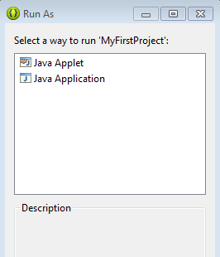

* 1. Select the console tab and should see the following

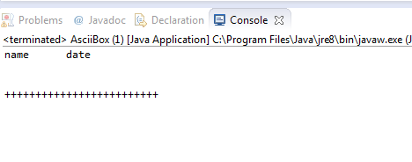

* 1. If get the following error then make sure your Project is selected in the Package explorer (not the JRE System Library…):

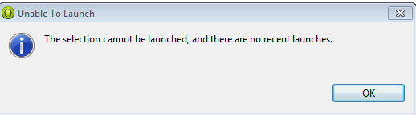

1. Double click the AsciiBox.java file in the package explorer to see the code. You will be modifying this code and other code files like it.